What is the Service Set Identifier (SSID) for the wireless router of your connection? Come on

What is the speed of your wireless connection? 65 Mbps

What is the MAC address of your wireless NIC? 00-F4-8D-22-17-DC

Do you have multiple IPv4 DNS Servers listed? If so, why would multiple DNS Servers be listed?

No.

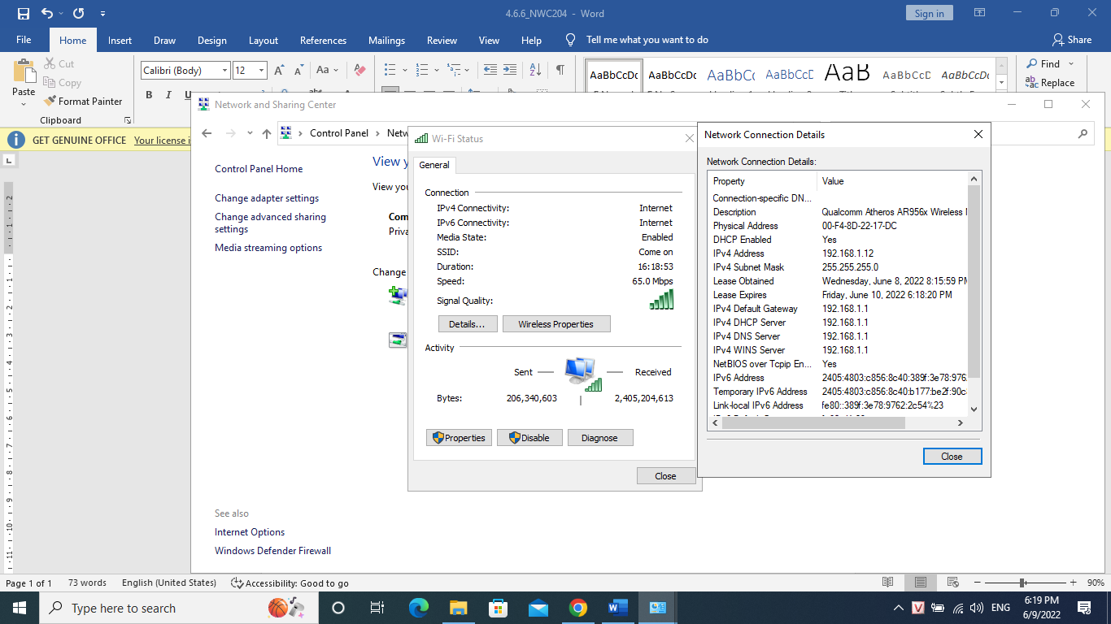Because when the first Sever is broken down, then the second Sever will take over to do the task

Why would you activate more than one NIC on a PC?

Because we can connect to not just one to network, but there are other ways to connect to network